

# MEASUREMENTS AND INSTRUMENTATION LAB

# MINI PROJECT

# 09/11/2023

|  |  |  |  |
| --- | --- | --- | --- |
| REGISTRATION NO. | NAME | ROLL NO | CLASS |
| 210906204 | **SHASHANK PANDEY** | **26** | **EEE-B** |
| 210906206 | **TITHI MISHRA** | **27** | **EEE-B** |
| 210906130 | **PRAANZAL PRAYAS** | **17** | **EEE-B** |

## TITLE

**PLANT CARE SYSTEM – SOIL MOISTURE AND LIGHT INTENSITY LEVEL DETECTOR**

## OBJECTIVES

1. **Main objective:** To make an efficient Plant Care System which takes care of our miniature garden even when we are not at home.
2. To measure the light intensity received by the phytotropins of plants.
3. To measure the moisture content of the soil and whether or not it’s adequate for our plant.
4. To measure the temperature of the environment and compare it with the optimum temperature required for plant growth.

## DESIGN

## WORKING PRINCIPLE

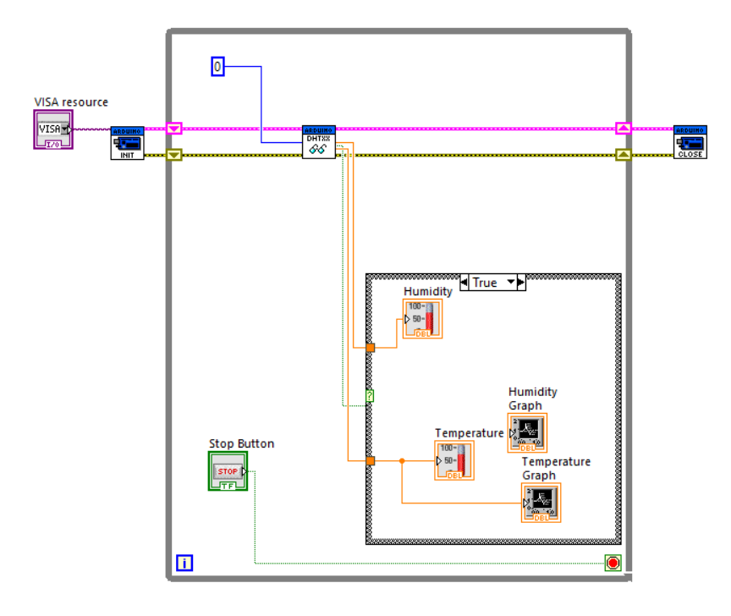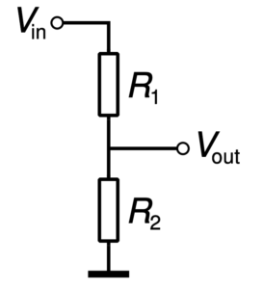

We have employed the DHT11 sensor for the Arduino Code and the LDR Sensor for light detection on the Cloud.

**Use of DHT11 Sensor**

The DHT11 sensor is a commonly used digital temperature and humidity sensor. It operates based on a capacitive humidity sensing principle and a thermistor to measure

temperature.

1. Capacitive Humidity Sensing:

* The DHT11 sensor contains a humidity-sensitive element that changes its capacitance with variations in the surrounding humidity levels.
* The sensor measures the capacitance of the humidity-sensitive element and compares it to the reference signal.

2. Temperature Sensing:

* + The DHT11 also includes a thermistor (resistor whose resistance changes with temperature) to measure temperature.
  + The resistance of the thermistor changes with temperature, which alters the voltage across it.

**Use of Voltage Divider Circuit**

A voltage divider circuit is a passive linear circuit that produces an output voltage (Vout) that is a fraction of its input voltage (Vin). The output voltage is a fixed fraction of its input voltage. The divide-down ratio is determined by two resistors.

## CIRCUIT DIAGRAM

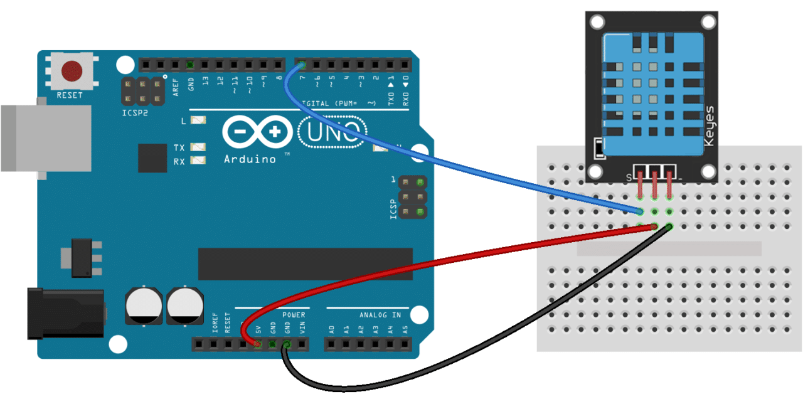

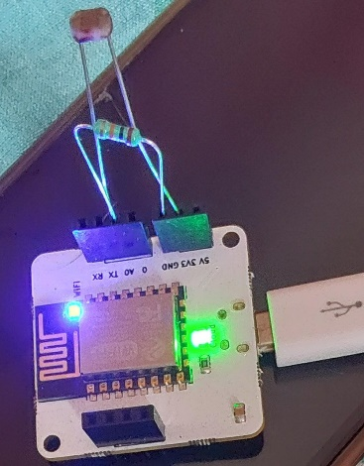

**Connections of Arduino and DHT-11:** The circuit diagram connection between an Arduino and a DHT11 sensor is a fundamental part of building a plant care system or any project that requires environmental monitoring.

* **Connect VCC of DHT11:** to the 5V output of the Arduino.
* **Connect GND:** to one of the GND pins on the Arduino.
* **Connect DATA (Data):** Connected to the A0 pin of Arduino. **Connection with the LDR Sensor**

The A0 pin is connected to the resistor and the LDR on one leg and the other leg of LDR goes to 3V supply.

## FLOWCHART

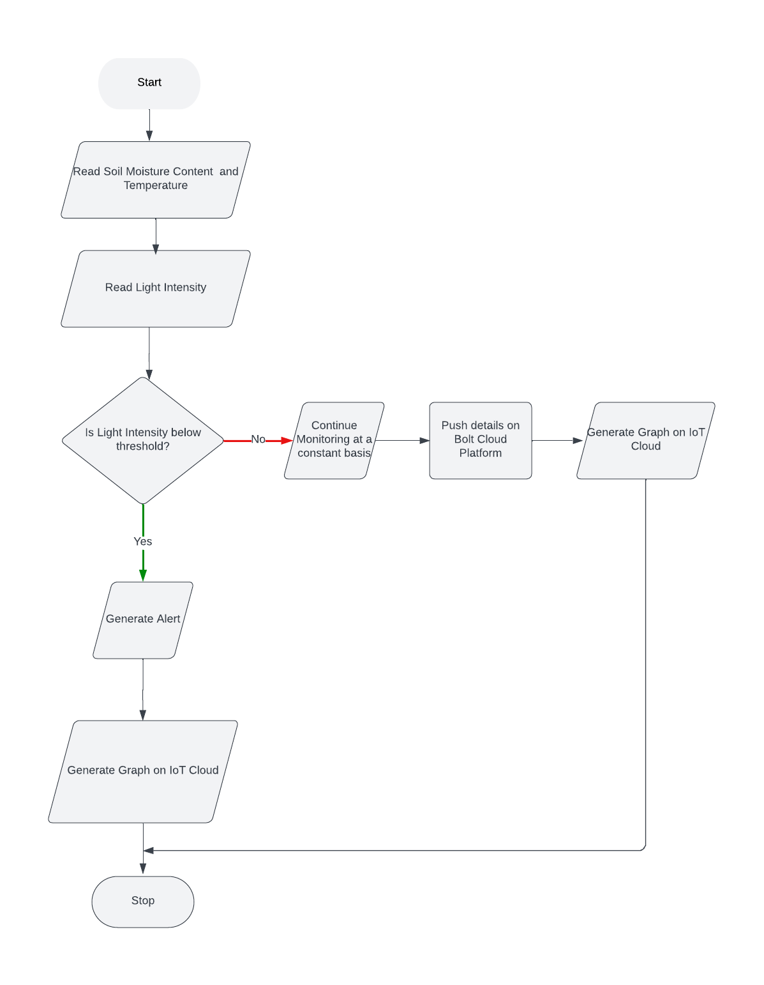

## SIMULATION RESULTS

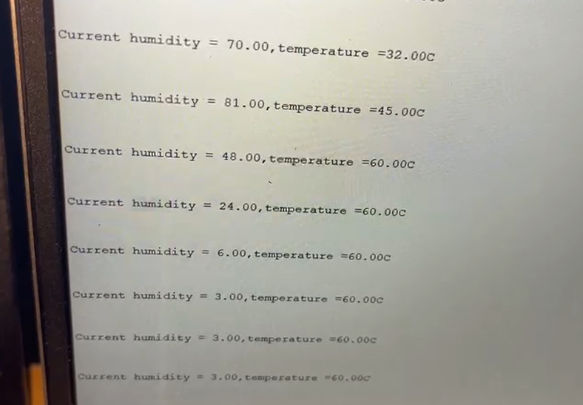

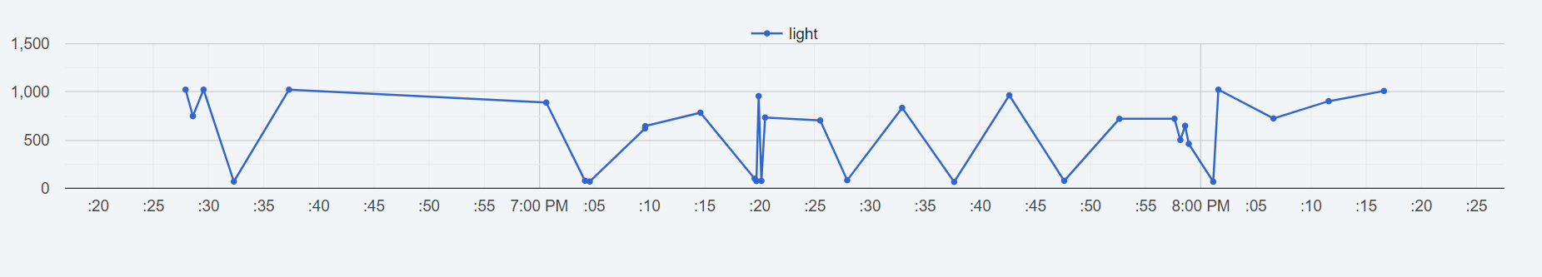

## HARDWARE

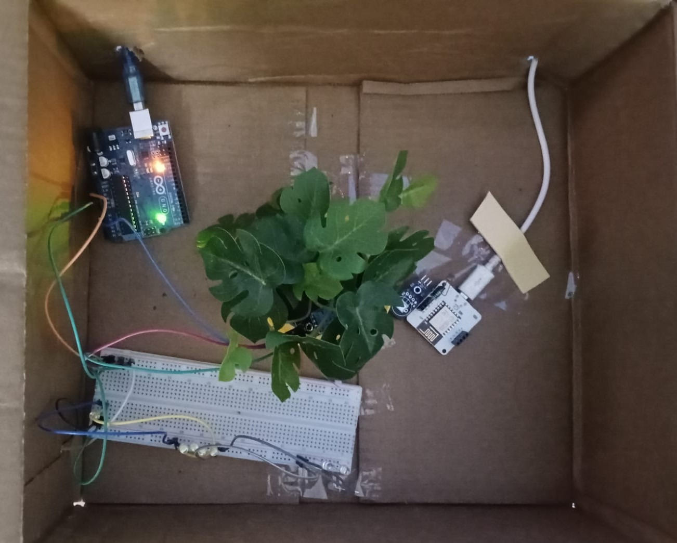

## CONCLUSION

The "Plant Care System – Soil Moisture and Light Intensity Level Detector" project represents a pioneering approach to addressing the growing need for efficient and sustainable plant care in various settings, including homes, gardens, agricultural fields, and urban environments.

This project aims to harness the power of modern technology to create a comprehensive and intelligent plant care solution that goes beyond traditional methods. By combining advanced sensors, Arduino, Wi-Fi Modules and user-friendly interfaces, this system endeavors to revolutionize how we nurture and sustain plant life.

## LIMITATIONS

1. Not integrating the switch to switch on the LEDs in the house through a Mobile/ WebApp.
2. **Sensor Accuracy:** The accuracy of the sensors used in the system may not be perfect. There can be variations in sensor readings, and over time, they might drift, leading to potential inaccuracies in data.
3. **Maintenance Requirements**: Over time, sensors and electronic components may require maintenance, calibration, or replacement, which can be a burden for users.
4. **Scalability**: Adapting the system for different plant types and environments might be challenging, and it may not cover all possible use cases.

# IMPACTS

An efficient plant care system with integrated light intensity monitoring and soil moisture level detection provides numerous benefits that extend beyond individual plant health. This system contributes to public health and safety, as well as cultural, societal, and environmental considerations, in the following ways:

1. **Public Health and Safety**
   1. Air Quality Improvement: Since plants play a crucial role in air purification by absorbing pollutants and releasing oxygen hence a healthy vegetation environment translates to cleaner air, which positively impacts respiratory health and reduces the risk of airborne diseases.
   2. Allergen Reduction: Well-maintained plants can reduce indoor allergens, lowering the occurrence of allergies or respiratory irritations.
   3. Stress Reduction: Researches have shown that the presence of greenery has been linked to reduced cortisol level hence decreasing stress levels and improved mental well-being.
2. **Environmental Considerations**
   1. Biodiversity Support: Maintaining healthy plant ecosystems supports local biodiversity by providing habitat and food sources for various species, including pollinators.
   2. Carbon Sequestration: As plants capture and store carbon dioxide, a thriving plant environment helps reduce greenhouse gas emissions and supports sustainability efforts.
3. **Sustainability and Resource Conservation**
   1. Water Efficiency: Integrating a soil moisture level detection system helps optimize watering practices, minimizing water wastage and promoting responsible water usage.
   2. Energy Conservation: The light intensity monitor ensures that plants receive the appropriate amount of light. This reduces energy consumption associated with excessive lighting and contributes to energy-efficient practices.

## BILL OF MATERIALS

|  |  |  |
| --- | --- | --- |
| Serial No. | Component | Price |
| 1. | Arduino UNO x 2 | 1600/- |
| 2. | Bolt Wi-Fi Module | 1500/- |
| 3. | Breadboard | 50/- |
| 4. | Light Detecting Resistor | 80/- |
| 5. | Jumper Wires | 50/- |
| 6. | DHT11 Sensor x 2 | 200/- |
|  | LEDs (Pack of 5 different Colours) | 80/- |
|  | Resistor Kit | 50/- |
|  | Extra Supplies | 500/- |
|  | Stationery | 200/- |
|  | Logistics and Travel | 400/- |
|  | TOTAL | 4710/- |